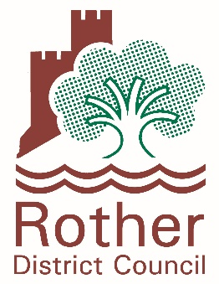
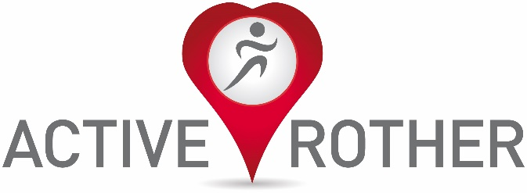

Active Rother Small Grants Programme 2022
Guidance and Application Form
Applications are invited for funding that meets the criteria set out in the programme guidance. Only applications made using this form will be accepted.

This small grants programme has two elements:
- Workforce development grants to supports coaches and instructors to develop their skills and create new opportunities to engage more effectively with inactive adults (age 16+) within targeted areas and population groups in Rother.
- Session delivery grants to set up new sessions or increase the opportunities for new inactive people to take part in existing sessions.

Applications are invited to cover one or both elements. Before you apply, please ensure you have read the following guidance carefully.

Guidance

This is a small grants programme brought to you by Rother District Councils’ Active Rother programme in partnership with Active Sussex, for grants up to £650. (Note that larger grants may be offered in exceptional circumstances, but please contact us before submitting a larger grant applications).

Grants can be used to:
- Attend training to enable you to engage with more inactive participants at your current sessions, for example training around behaviour change or marketing.
- Increase the number of coaches in your club by training more volunteers to level one, two or three.
- Qualify you to deliver a new activity.
- Qualify you to work with special populations, such as people with specific long term conditions or disabilities.
- Set up new sessions or increase the opportunities for inactive people to take part in your existing sessions. Please be aware that a plan must be in place for sustainability of sessions to ensure they can continue once the grant funding is spent.

All training should be accredited. If you wish to attend training that is not accredited, you will need to provide evidence that the training is of a high standard and is suitable for the aims of the project.

Priority will be given to individuals, projects or clubs working with people who are finding it more difficult to be active at this time, with a focus on the following Active Rother priority population groups and areas/communities.

Priority population groups:
- Older people
- People with disabilities
- People with long term health conditions
- People on low incomes

Priority areas/communities
- Sidley
- Bexhill - Sackville
- Bexhill - Central
- Pebsham
- Rye
- Eastern Rother – Camber

Who can apply?

Organisations based in or providing physical activity opportunities for adults (16+) within Rother.

Requirements

Individuals/groups/organisations should have:
- A bank account
- Public Liability Insurance (£5m) and Employers Liability Insurance if relevant (£5m)
- The relevant prerequisite qualifications required to attend the training course
- A recent DBS check if working with vulnerable adults
- Policies to include a safe session including a risk assessment
We will need to see copies of these documents before paying a grant.

Please note, we are also keen to

Reporting

If your application is successful you will be required to return monitoring paperwork to show how the training and/or session delivery has enabled more people to be active. This will be agreed when confirming the grant, but will involve distributing and gathering in and returning to us, survey responses from participants attending sessions.

All training must be completed, and new sessions must commence by 31st June 2022 (this may be extended if a case can be made based on training availability)

How to apply

Any application for this programme should be made using the accompanying application form. Only applications made using this form will be accepted.

The deadline for applications is 5pm on Monday March 7th 2022. A further opportunity may be available later in 2022, but we are not able to guarantee this at this stage.

Once we have identified the applications which are suitable to receive a grant, we will contact applicants to agree specific conditions and monitoring requirements, prior to confirming the actual grant award. Payment of the grant will be via an invoice to Rother District Council.

Further information

For further information and/or to discuss a potential application, please contact:
Stuart Ramsbottom - Active and Healthy Communities Specialist (working Monday, Tuesday and Wednesday)
stuart.ramsbottom@rother.gov.uk

or
Adrian Gaylon - Sports Development Officer
adrian.gaylon@rother.gov.uk

Application Form

Section 1 - Applicant Details

Name
Postal Address

Postcode

Phone Number

E Mail Address

Section 2 – Individual/Club/Organisation Who Application Relates To
Name of Individual/Sports Club/Organisation

What activities do you currently provide?

Role of Applicant within Club/Organisation

Postal Address (if different from above)

Postcode
Phone Number (if different from above)

Email Address (if different from above)

Section 3 – Your Project
Are applying for a grant to fund training, session delivery or both?
  Training
  Session Delivery
  Both
What amount of funding are you applying for?

Please provide a breakdown of all costs which make up the amount being applied for.

Have you secured any other funding for the project? If so, please provide details.

What training are you applying for? Please include the course title, provider and course dates (if known).

Is the training accredited?

What will this training enable you to do and how will this benefit Rother residents?

Tell us about the person(s) attending the training. What skills do they have?

Who will your project target from within our priority groups? How to you know there is a need for activities for this target group(s)?  Are there any other population groups in that could benefit?
  Older people
  People with disabilities
  People with long term health conditions
  People on low incomes
Which of our priority areas will your benefit from your project?  If your project will not benefit any of our priority areas, how will you ensure that participants from these areas can benefit?
  Sidley
  Bexhill - Sackville
  Bexhill - Central
  Pebsham
  Rye
  Eastern Rother - Camber
Are these new sessions or an expansion of existing activity?

What forms of advertising and promotion will you use to engage your target audience?

How will you sustain your classes once the funding has finished?

Is there anything else you would like to tell us?

Please submit completed application forms to Stuart Ramsbottom, Active and Healthy Communities Specialist at Rother District Council, Town Hall, Buckhurst Road, Bexhill on Sea, TN39 3JX or email to stuart.ramsbottom@rother.gov.uk

The deadline for applications is 5pm on Monday March 7th 2022.

Should anyone require this document in another format, such as larger print, please contact Adrian Gaylon or Stuart Ramsbottom

